Economy
The economy is the wealth and resources of a country.
A country’s economic factors have an impact on the well-being and ways of life of people. These factors include employment, technology, access to resources and services, international trade, urbanization, and industrial development.
We’ll look at the relationship between development and quality of life, and economic factors and issues that affect the well-being and daily life of people living in a selected society of Asia, Africa, or Australasia.
But first, some background knowledge!
Part 1: What is an economy?
How Economies work
- United States - market economy
- Sweden - mixed economy
- China - command economy
- Inuit communities - traditional economy
- Bhutan - traditional economy
- North Korea - command economy
- Japan - market economy
- United Kingdom - mixed economy

Vocabulary

- Market economy
- Command economy
- Traditional economy
- Mixed economy

A country’s economy is measured by its GDP (gross domestic product) which we discussed when we learned about the ‘good life’. The GDP is the value of the goods and services produced.
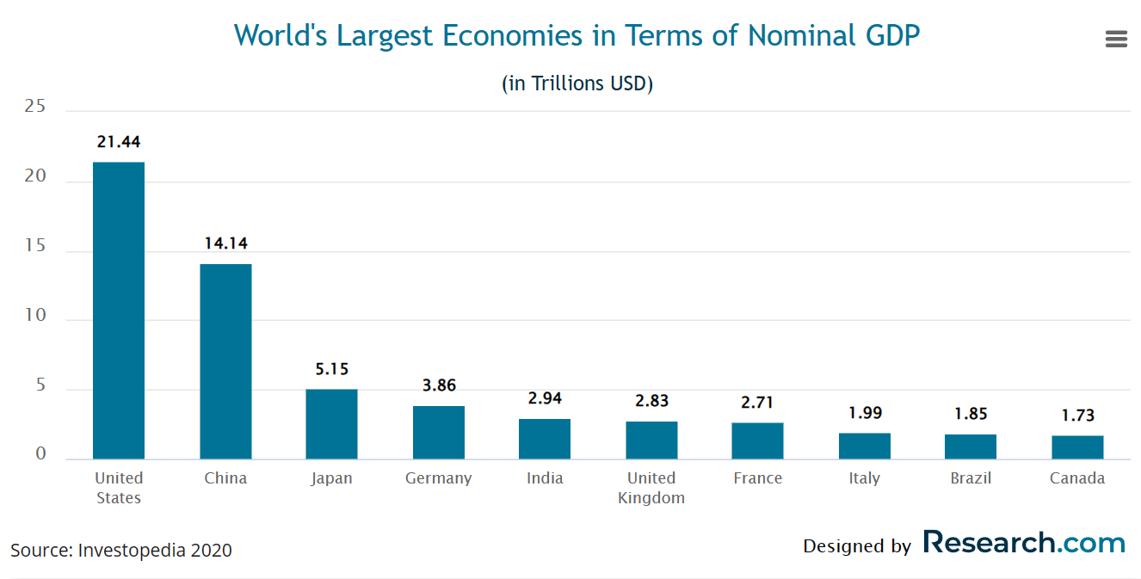

Economies depend on three things:
- Natural resources ex:
- Human resources ex:
- Capital resources ex:
Understanding Economies
- Assignment: We will play a game to learn how economies develop. After playing the game, write a reflection on how economies work and what you learned about them. You will be assessed on your response.

Part 2: What is a globalization?
Globalization and Trade and Poverty: Crash Course Economics #16 - YouTube
Vocabulary
- Globalization
- Tariffs
- Child labor
- Fair Trade
- Assignment: Is globalization good or bad? Explain your opinion.
A Deep Dive into Globalization
Where do the things you buy come from?
- Assignment: Try to find items from as many different countries as possible. Take a photo of the label, tag or sticker for verification purposes. (You can begin by looking in the classroom.)

Part 3: Child Labor & Forced Labor
Vocabulary
- Child labor
- Forced labor
- Sweat shops
- Exploitation
- Assignment: Watch two of the videos and record the 5W’s (Who, What, Where, When, Why is it a problem?) All links are on the weebly.

What can you do?
What can Canada do? Watch Global News link on the weebly.
- Assignment: Create a TikTok video or write a letter to the Winnipeg Free Press explaining your point of view on the role you, as a young Canadian, have in preventing forced and child labor.

