Grade 7/8 Social Studies Unit 1: Mapping
You will label ___ maps.
Map #1: World Continents & Bodies of Water

- Equator
- North Pole
- South Pole
- Prime Meridian
- Tropic of Cancer
- Tropic of Capricorn
- Arctic Circle
- Antarctic Circle
- International Date Line
Continents
- North America
- South America
- Europe
- Asia
- Oceania
- Antarctica
- Africa
Global Ocean
- Atlantic Ocean
- Pacific Ocean
- Southern Ocean
- Indian Ocean
- Arctic Ocean

Map #2: Major Climate Zones
- Tropical Zone (hot and humid) has a monthly mean temperature of 18 degrees Celsius.
- Dry Zone (desert or arid) loses most of its precipitation to evaporation.
- Temperate Zone (mild) has a wide range of temperatures and are between tropical and polar regions.
- Continental Zone (cold and humid) has cold winters and hot summers and is located on large masses of land.
- Polar Zone (very cold and dry) has an average monthly temperature of less than 10 degrees Celsius. They have cool summers and very cold winters.
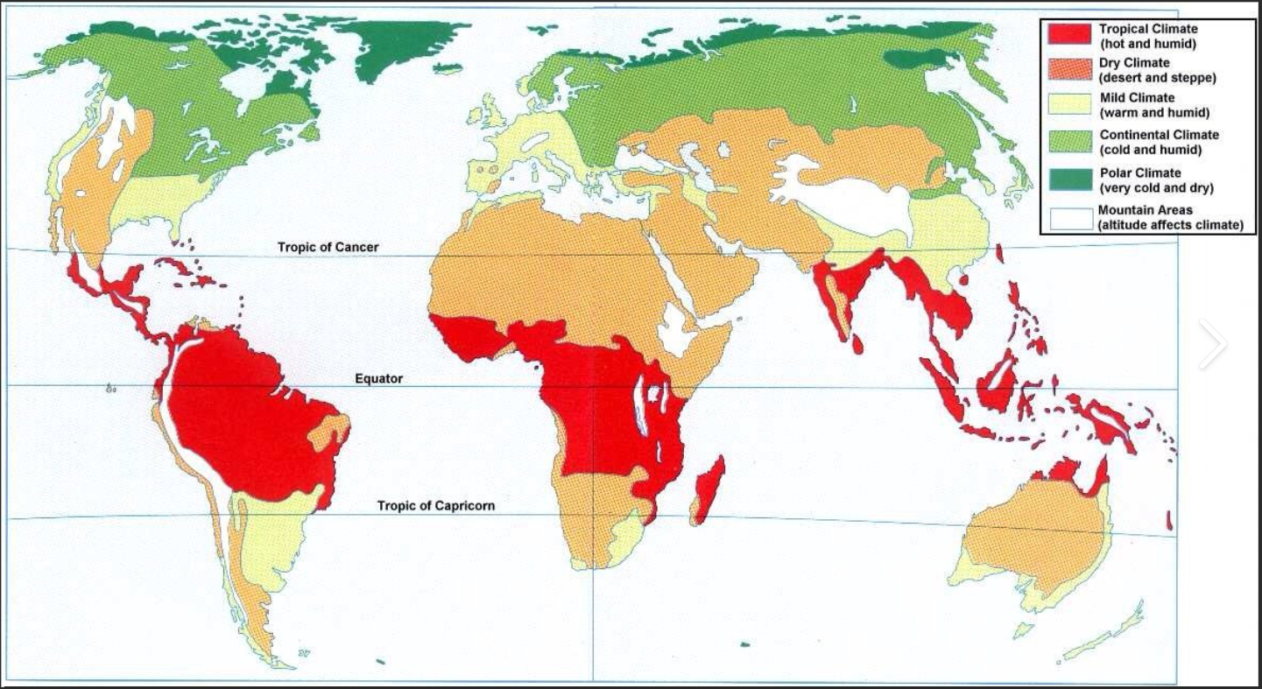
Map #3: Major Population Clusters
What are 5 assumptions you can make about population clusters?
Use Ranked: The 20 Most Populous Cities in the World (visualcapitalist.com) to label the cities with the highest populations on your ‘Outline map of countries of world’
Map #4: Developed and Developing Countries
Create a legend that includes:
- Least Developed
- Developing
- In transition
- Developed
Use Countries grouped by United Nations - Vivid Maps to fill in your map.
Use arcgis.com/apps/instant/atlas/index.html?appid=0cd1cdee853c413a84bfe4b9a6931f0d&webmap=3871d636011b4101abfcbc75bef46802 to label 5 major cities (look for larger circles) in each region.

