Grade 7/8 Social Studies Unit 1: Mapping
- _________________The distance north or south from the equator.
- _________________The distance east or west on the earth's surface from the Prime Meridian.
- _________________Lines on a map that show distance in latitude
- _________________A longitudinal line that circles the earth passing through the North and South Poles.
- _________________A latitudinal line that is equidistant from the North Pole and South Pole.
- _________________Half of a sphere (like Earth).
- _________________The combination of weather conditions like temperature, air pressure, humidity, precipitation, sunshine, cloudiness, and winds, averaged over a series of years.
- _________________All the plant life of a place
- _________________The number of people living in an area.
- _________________The number of people living in a certain area which measures how crowded a place is.
- _________________These 24 regions determine time based on their distance from the Prime Meridian.
- _________________ This longitudinal line is where the new day begins. It runs through the Pacific Ocean. The Prime Meridian in Greenwich, England is 12 hours behind it.
- _________________To settle and establish a new colony.
- _________________An international organization that promotes peace, security, and cooperation across all member nations.
- _________________Fundamental rights for all humans which have been agreed on by the United Nations.
- _________________Manufacturing or production of goods.
- _________________The consumption (use), production, and trade of goods and services.
- _________________Employing children below legal working age.
- _________________A person who must leave their homeland because their life is in danger.
- _________________Permanently moving to a new country.
- _________________Leaving your country of residence for a new one.
- _________________When a city’s population and economy grow making more services available.

Child labor
Climate
Colonization
Economy
Emigration*
Equator
hemispheres
Immigration*
Industry
International Date Line
Latitude
Longitude
Meridians
Parallels
Population
Population density
Refugee
Time zones
United Nations
Universal human rights
Urbanization
Vegetation

*Immigrant and emigrant both refer to a person who leaves one country for another. An immigrant emphasizes the country of destination, while emigrant emphasizes the country of origin. For example, a person who moves from China to Canada is an immigrant to Canada and an emigrant from China.

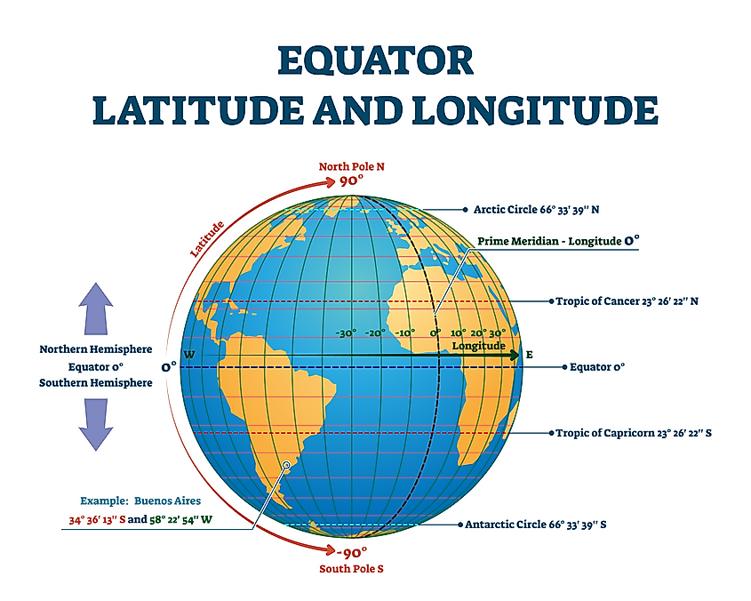
Source: www.worldatlas.com

